МБОУ «Шенкурская средняя школа»
2018-2019 учебный год

Сборник упражнений по теме:
«Страдательный залог / The Passive Voice»

Составитель: Доильницына Е. Ю.,
учитель английского языка

Страдательный залог / The Passive Voice

«Формула» страдательного залога:
глагол to be в форме соответствующего времени + смысловой глагол в 3 форме.
to be + V3

Третья форма глагола также называется: причастие II / Participle II / Past Participle.
У правильных глаголов третья форма образуется прибавлением – ed, у неправильных глаголов – особые формы, которые можно найти в таблице неправильных глаголов.

Страдательный залог используется, когда действие направлено на предмет или лицо, выраженное подлежащим. Если указано, кем выполняется действие, то употребляется предлог by; если указано с помощью чего – предлог with.
A lot of plays were written by William Shakespeare.
East Asian food is eaten with chopsticks.

Таблица времён английского глагола в страдательном залоге
 | Simple Passive | Progressive Passive | Perfect Passive
Present | am  is + V3  are | am  is being + V3  are | have  been + V3  has
Past | was  + V3  were | was  being + V3  were | had been + V3
Future | will be + V3 | - | will have been + V3

 | Simple Passive | Progressive Passive | Perfect Passive
Present | Letters are written  every day.  Письма пишут каждый день. | The letters are being written now.  Письма пишут сейчас. | The letters have already been written.  Письма уже написаны.
Past | These letters were written yesterday.  Эти письма были написаны вчера. | The letters were being written at that moment.  Письма писали в тот момент. | The letters had been written by 11 o’clock .  Письма были написаны к 11 часам.
Future | The letters will be written tomorrow.  Письма будут написаны завтра. | - | The letters will have been written by 11 o’clock.  Письма будут написаны к 11 часам.

Упражнения, направленные на активизацию использования в речи
форм страдательного залога.

I Fill in the gaps with the words:
- will be - are - was - is - were

1) These roses … planted last year.
2) Yesterday I … told an interesting story.
3) The game … organized next week.
4) The flowers … watered every three days.
5) The flat … cleaned on Saturday.
----------------------------------------------------------
- cleaned - found - invited - finished - founded - invented

1) How many scientists were … to the conference?
2) Is the park … in spring?
3) When will the work be …?
4) Whom was paper … by?
5) St Petersburg was … by Peter I.
6) The maps were … in the old bookcase.

II Put the words in the correct order to make sentences.
1) the streets, cleaned, how often, are ?
2) in, the 2000 Olympic Games, Sydney, held, were.
3) will, the actor, about his new role, be, asked.
4) being, the new uniform, is, bought.
5) was, offered, she, any help ?
6) have, I, just, to a concert, been, invited.
7) being, these, read, books, are ?
8) yet, his letter, answered, hasn’t, been.
9) translated, will, when, be, the text ?

III Make the gaps between the words to make sentences.
1) Thesefruitaregrownintropicalclimate.
2) Havetheapplesbeenwashed?
3) Themeatisbeingcooked.
4) Howmuchweretheypaidlastmonth?
5) Theflowerswillbeplantednextweek.
6) Howmanyhousesarebeingbuiltinyourtown?
7) Thefestivalisorganizedeverysummer.
8) Byeighto’clockallthefoodhadbeeneaten.

IV Translate the sentences into Russian. Which Passive form is used in the sentences?
1) The floor in the kitchen is being painted.
2) Has the report been written yet?
3) The weekend plan was being discussed at that moment.
4) The homework will have been done by 5 o’clock.
5) The cake had been baked when the guests arrived.
6) Sandra and Diana are being told about the new project when I came home.
7) The letters have just been posted.

V Translate the sentences into Russian. Find Passive forms.
1) How much were you paid last month?
2) Mike has got a good car.
3) Newspapers are sold in the kiosk.
4) They sold their old house a year ago.
5) Tom is never late.
6) The text on page 69 has just been translated.
7) When will the concert be held?
8) The project is being discussed.

VI Choose the necessary form.
1) The classroom … now.
A- had been cleaned B- is cleaned C- is being cleaned D- was cleaned

2) The work … yet.
A- has not been done B- have not been done C- was not done D- were not done

3) The report … from Wednesday to Friday last week.
A- was being written B- had been written C- will be written D- is being written

4) Yesterday I … to a party.
A- am invited B- was invited C- have been invited D- will be invited

5) How many houses … in your region every year?
A- have been built B- are being built C- had been built D- are built

VII Complete the sentences with the third form of the verbs:
a) sell b) build c) paint d) translate e) show f) visit g) teach h) pay

1) The floor in my room is being … .
2) How much was he … for that invention?
3) I was … to swim when I was five.
4) Edinburgh will be … by the Queen next week.
5) Their house was being … at that time.
6) Are toys … in this shop?
7) Were these books … into French?
8) My favourite programme is … on Saturday evenings.

VIII Rewrite the sentences using Passive forms.

Example: I washed the windows yesterday. – The windows were washed yesterday.

1) She was decorating the room at that moment.
2) I have found some interesting information today.
3) Ann will buy a present for Nick.
4) We changed the plan last week.
5) By 11 o’clock tomorrow he will have brought the books.
6) Ron is watering the vegetables.
7) Brother had washed the jeans by 7 o’clock yesterday.
8) Pupils often use these computers.

IX Answer the questions using Passive forms.
1) When was Shakespeare born? | 
2) Are the rivers in your place covered with ice in winter? | 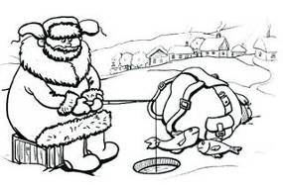
3) Is your dictionary being used at the moment? | 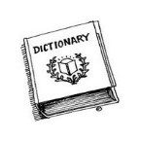
4) Had your house been built before 2000? | 
5) Will the park be cleaned in spring? | 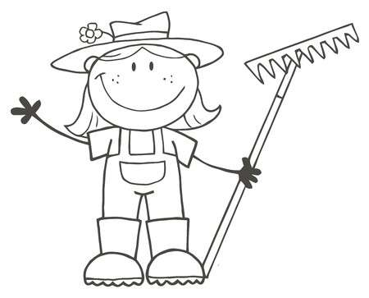
6) How often is bread bought? | 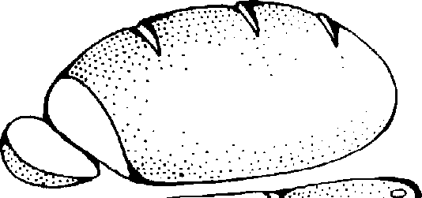
7) When is a tall New Tree put up in the central square  of your town? | 
8) Was the classroom being cleaned  when you came to school in the morning? | 

Использованная литература:

1) Клементьева Т. Б., Шэннон Д.
Счастливый английский. Кн. 2 для 7-9 кл. общеобразов. шк. – Обнинск: Титул, 1997

